Who failed Traevon? A Cree teen’s death in an Indigenous agency’s group home points to a ‘broken’ system
Xyolhemeylh is the largest of the Indigenous-led foster agencies in B.C., but people who once lived in its care say they faced neglect and abuse – and mourn for the 17-year-old who never made it out alive
NANCY MACDONALD
ABBOTSFORD, B.C.
PUBLISHED APRIL 23, 2022
A former group home in Abbotsford, B.C., is seen in the fall of 2020. Two months earlier, Traevon Desjarlais-Chalifoux, a resident of the home, died by suicide. He was 17.

When Traevon Desjarlais-Chalifoux arrived at the group home at 2258 Ware St., on a busy thoroughfare in Abbotsford, B.C., he was a boy in crisis. His uncle – who was more like a father – had been diagnosed with a terminal illness. Traevon, a 17-year-old Cree boy with shoulder-length hair and a shy smile, was shattered by the news.
He’d been assigned a bedroom in the basement of the faded ranch-style house with peeling white paint, a staircase away from Jamie, an Anishinaabe boy one year his senior. Xyolhemeylh, the Indigenous child welfare agency tasked with caring for the boys, told Jamie that its staff would help him turn his life around after years of horrific abuse at the hands of his dad.
But the agency failed both boys. Jamie left the home a few months after Traevon arrived in January, 2020. Traevon never made it out.
Xyolhemeylh (pronounced yoth-meeth) is one of 24 Indigenous Child and Family Service agencies charged with providing foster care to First Nations, Metis and Inuit children and youth in B.C. Xyolhemeylh, in turn, contracted out the boys’ care to a company called Rees Family Services Inc., which runs 10 Fraser Valley group homes. Rees promised round-the-clock treatment that was “safe, supportive” and “trauma-informed,” according to the accreditation agency used by B.C.’s Ministry of Children and Family Development, or MCFD.
Instead, the care workers were variously verbally abusive, neglectful or casually indifferent, according to Jamie’s sister Liz and a trail of text messages the two exchanged during Jamie’s time at the home. The workers sometimes withheld food as punishment and locked the boys outside when they left to run errands – sometimes for hours at a time – measures The Globe and Mail confirmed in an interview with a worker employed by Rees to care for them. No attention was paid to the boys’ First Nations backgrounds, and both workers who cared for them were white, Jamie says. (Privacy legislation bars The Globe from identifying Jamie and his sister, who were both in foster care.)
Traevon, who was small and slight for his age, “got the worst of it,” according to Jamie, “because he would fight back.”
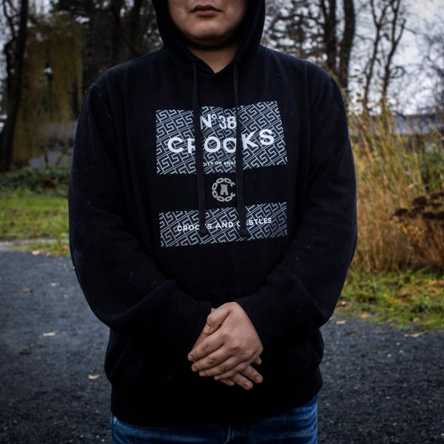
Jamie, an Anishinaabe boy, left the group home in Abbotsford months before Traevon died.RAFAL GERSZAK/THE GLOBE AND MAIL
Jamie left 2258 Ware in March, 2020. He chose to return to the home of his abusive father rather than continue living there. Six months later, in September, 2020, Traevon died by suicide. It took four days for anyone to find his body in the closet of his tiny basement bedroom.
The B.C. Coroner’s Service says it is investigating Traevon’s death. The B.C. Representative for Children and Youth, Jennifer Charlesworth, told The Globe she is “very concerned about this case” and has conducted a comprehensive review. A decision about whether to issue a public report will not be made until after the coroner’s work has concluded. No new information about Traevon’s death has been released in the 18 months since, but a new report by Ms. Charlesworth labels the system of funding child welfare services for Indigenous kids in the province “broken,” and in urgent need of an overhaul.
It is not known how many children and youth are dying in group homes in B.C., nor whether these deaths have reached crisis levels. The MCFD and the B.C. Coroner are refusing to provide answers to these questions. What is known is that the ministry has, so far, reviewed the deaths of 45 youth who died in care in 2018 and 2019, although it won’t say how many of them lived in group homes. Of those, 62 per cent were Indigenous. Even that nominal data point is not released or easily ascertained.
This will be only the most recent investigation into Xyolhemeylh, the largest of the province’s Indigenous Child and Family Service agencies. Repeated audits and investigations into both Xyolhemeylh and the MCFD have shown that neither is adequately monitoring group homes to ensure they are safe and secure for the children who live there. No guardrails are in place to ensure that staff hired by group home operators are equipped to care for some of the most vulnerable, high-needs youth in the province. Neither the ministry nor Xyolhemeylh are ensuring the care Indigenous youth receive in group homes like the one run by Rees are culturally appropriate and safe.
A Globe review of Xyolhemeylh’s recent practice audits found a pattern of omission and neglect on a range of metrics, including a failure by social workers to meet regularly with young people in their care or to plan adequately for their care. In some cases, they never met with them at all.
The audits found similar deficiencies across the five largest agencies. But they were most stark at Xyolhemeylh, which has the highest case load of any Indigenous agency – 560 child service cases, compared with 360 for its Vancouver equivalent, the Vancouver Child and Family Services Society, according to ministry data. It has had several high-profile tragedies involving youth in its care. In 2015, Alex Gervais, an 18-year-old Métis boy in Xyolhemeylh care, lived for months in an Abbotsford Super 8 – in violation of government policy – before falling to his death from a hotel window.
Xyolhemeylh did not respond to requests for comment on its practices or on the care provided to Traevon. The MCFD has not responded to questions about Traevon’s case, including why he was taken from his family and placed in the agency’s care, or its oversight of Xyolhemeylh specifically, citing privacy and confidentiality concerns.
There are many questions left to be answered. For one, why did Xyolhemeylh not try to place Traevon with a member of his large, extended family? Denise Desjarlais, an aunt in Chilliwack, B.C., told The Globe she would have taken in her nephew had she been alerted he was in care. The boy’s mother, Samantha Chalifoux, hasn’t received answers to even more basic questions, her lawyer, Sarah Rauch says. When was Traevon last seen alive? Who saw him last? Did care workers search for him over the four days he was missing? Was anyone in the home with him in the days before he died? And why did it take so long for her son’s body to be discovered?
In a complaint filed to the B.C. Human Rights Commission last summer, Ms. Chalifoux alleges she has been refused access to information about her own son and “denied the opportunity to meaningfully participate in or remain informed of investigations and discoveries” about him. The ministry is refusing to even provide her with her son’s file. At every turn, she was “dismissed, belittled” and “treated with indecency,” she says in her statement to the commission. Ms. Chalifoux declined to speak with the Globe and Mail. She asked her paternal aunt, Theresa Campiou, to speak on her behalf.
Xyolhemeylh has yet to return one of Ms. Chalifoux’s phone calls, Ms. Rauch notes. “Not only does this lack any kind of dignity or respect, but it seems like someone is trying to hide something,” she says. “And that’s a problem.”
Samantha Chalifoux is a member of the Driftpile Cree Nation, on the southern shores of Lesser Slave Lake in northern Alberta. The 40-year-old lost her mother in a car accident when she was seven. It was the first in a series of tragedies that destroyed her little by little, says Ms. Campiou, a Cree Elder and accountant.
Of the five children in her family, just Ms. Chalifoux and her brother Phillip survived their twenties, says Ms. Campiou. “She’s done the best she can. I’m proud of her.” Throughout her struggles, Ms. Chalifoux continued to play an active role in her son’s life.
Traevon was born in 2003. His father is a member of the Sunchild First Nation, a neighbouring Cree nation. Traevon spent part of his childhood with a paternal aunt and her four children in the Fraser Valley city of Mission. There, he shared a bedroom with his uncle Steven Desjarlais.
Until he was a toddler, Traevon slept on his Uncle Steven’s chest. “Get on my belly, get on my belly,” Mr. Desjarlais would whisper when Traevon woke in the night. He was Traevon’s “mother and his father – his everything,” says his aunt.
Mr. Desjarlais was a big kid at heart. He loved to play with his nieces and nephews and once brought home a shopping cart filled with candy to cheer them up.
But when Traevon was 11, he was taken into ministry care. Ministry officials and family members have declined to say why, citing privacy concerns. Neither Traevon nor his Uncle Steven ever seemed to recover from the abrupt separation.
Aaron Hannam briefly cared for Traevon in 2015, in an Abbotsford group home. Traevon, then 15, was quiet, delicate and small — “no more than 5-foot-4,” says Mr. Hannam.
Most of the boys in Mr. Hannam’s care used drugs, were often violent, and cycled in and out of youth detention facilities. Traevon, by contrast, was considered “low-risk,” he says, and had no police record. Ms. Chalifoux’s lawyer adds he had no mental health or behavioural issues. Mr. Hannam remembers a “good kid who walked to his own beat.”
He just didn’t want to be in foster care, Mr. Hannam adds. Soon after arriving at the group home, Traevon left to stay in a Mission flop house, where kids were known to drink and smoke pot unsupervised, he says. Mr. Hannam was upset when Traevon’s social worker at Xyolhemeylh allowed the teen to stay at the flop house rather than return to the group home. He was concerned for his safety and well-being.
In all, Traevon spent six years cycling through multiple foster homes and was in the care of dozens of social workers and paid caregivers before landing at the group home on Ware Street. According to Ms. Rauch, Ms. Chalifoux’s lawyer, Traevon was being bullied in the group home and was assaulted in or near it.
By then, Jamie had already been at Ware Street for several months. The home was supposed to provide a fresh start, away from the violence of his home life. His Anishinaabe culture was meant to be nurtured and encouraged. “I felt like I could turn my life around,” says Jamie.
Instead, he says workers who rotated into the home every 72-hours and who were supposed to look after him and Traevon spent their time on their computers, watching TV and sleeping. Jamie, who has fetal alcohol spectrum disorder and developmental delays, says he and Traevon were often left alone in their bedrooms, sometimes for 12 hours at a time.
One night in the spring of 2020, Jamie texted his sister: “I need to get out of here.” One of the workers, whom he knew only as Brett, was yelling and belittling him. “I’ve been crying for over an hour now. I can’t stop.”
Liz asked what he needed. “To get out of here for awhile so I don’t end [up] killing myself. I can’t take it anymore. I can’t live here. He’s acting like dad. It scares me,” Jamie wrote.
One of the workers, Murray McMaster, acknowledged to The Globe that he “made [Jamie] wait outside” when he went shopping. “I often invited him along; he always refused.” He added: “I can’t discuss this any more with you, there’s confidentiality agreements in place.”
In a text message, Liz asked Mr. McMaster why Jamie’s care workers needed to resort to threats when trying to get him to do something: “I’m sure you know he comes from [a] place of violence,” she added.
“What I see is a youth… ageing out [of care] in 6 months,” Mr. McMaster replied. “If we do not prepare him now with some good habits, to put it bluntly, he will be screwed.”
An MCFD spokesperson declined to specify the qualifications required of workers hired by group home subcontractors, but did say that regulations bar care workers from withholding food and leaving youth outside group homes.
Caring for children in group homes costs the B.C. government an estimated $103,200 per child annually, compared with $22,700 for foster-family care. Xyolhemeylh cares for children and youth from 18 First Nations across the Fraser Valley. This can make face-to-face individual meetings with the youth in their care difficult, a 2020 audit by the MCFD showed. High staff turnover is chronic. Staff vacancies go unfilled for long periods of time.
Annabelle Jarman Delorme says the care she received from Xyolhemeylh was “awful.” The Métis-Cree 19-year-old from Chilliwack says she was assigned upwards of 40 social workers in her five years with the agency. She sometimes went years between visits.
Twice, she was left to find foster parents for herself, she says. In 2016, when she was 15, she moved 700 kilometres north, to Prince George, to live with a stranger, paying the $250 bus fare herself. A woman there had agreed to take her in for the $900 monthly ministry cheque. Ms. Jarman Delorme refused Xyolhemeylh’s many attempts to place her in a group home because she’d heard how “dangerous” they were.
“I spent my entire youth fighting Xyolhemeylh to pay attention, to help me get out of dangerous living situations,” says Ms. Jarman Delorme. “I’m only here because I fought to be here, not because of anything Xyolhemeylh did.”
Concerns about Xyolhemeylh have been flagged repeatedly in ministry audits.
One, published in 2021, found that in 89 per cent of cases, the agency had no comprehensive plan for the children in its care. In 25 per cent of care homes, the required criminal records checks were not complete. Just 3 per cent of children saw their social worker once per month, as mandated by the ministry. In 10 per cent of cases, children didn’t see a social worker at all in the three-year audit period.
As a result of the 2020 audit, the MCFD says it developed an “action plan” with Xyolhemeylh to address certain “practice issues.” This included completing outstanding criminal records checks on contracted staff and reviewing policies and procedures with its social workers. That was the extent of its demands on the agency.
Xyolhemeylh was founded in 1993 by the Sto:lo Nation. It was the agency responsible for two-year-old Chassidy Whitford, who was killed in 2002 by her father. He had been allowed to continue caring for the toddler despite her unexplained injuries, a subsequent investigation found.
The girl’s murder seemed to deepen a political schism that divided the 21 bands who make up the Sto:lo. Some began barring the agency’s social workers from reserve lands. In 2006, agency head Jimmy George stepped down when it was made public that he was a convicted child sex offender.
The ministry took over the troubled agency the following year and did not restore its child-protection powers until 2010. Five years later, Alex Gervais died by suicide while under Xyolhemeylh care.
Like Traevon, the Métis teenager had cycled through dozens of homes, social workers and care givers, according to an investigation into his death. Xyolhemeylh also failed to connect him to his Indigenous culture.
The lack of oversight of the group home who cared for Alex prior to his motel placement “directly contributed” to his death, B.C.’s Children’s Representative concluded in a 2017 report. It called on the B.C. government to take “immediate action” to “significantly enhance” oversight of group homes.
In 2018, B.C.’s former Children’s Representative, Bernard Richard, again reiterated his “grave concerns” with group homes. He noted “yet another” private operator had closed in scandal, and the ministry’s operation and oversight of group homes continued to leave youth facing “unacceptable risk.”
He made these comments after learning that 18 children and youth had been relocated from a Lower Mainland group home because of claims that a staff member was gang-affiliated, took youth on drug drops, smoked marijuana with them and offered them cocaine. Just 10 of 33 agency staff had cleared criminal record checks. (Neither Mr. Richard nor the ministry would name the group home provider.)
A year after Mr. Richard voiced his concerns, provincial auditor general Carol Bellringer audited contracted residential services for youth in care. Ms. Bellringer concluded the ministry was failing to provide effective oversight or monitoring of group homes. Many of these placements weren’t “therapeutic” at all, according to Ms. Bellringer. They simply provide youth with “food and housing,” but no programming or services whatsoever, she wrote.
B.C., she suggested, is essentially warehousing Indigenous teens in rental homes staffed by people with no training or expertise in caring for profoundly traumatized, high-needs children. The government has now been warned repeatedly that the care these homes provide is sub-standard, unacceptable and creating extreme risks. As a result, Indigenous youth continue to die in these homes – mainly by suicide, drug overdose and preventable accidents.
The ministry accepted Ms. Bellringer’s recommendations. It says it has developed “new and stronger” rules for oversight and has begun “re-designing the procurement and contract management system with the goal of improving management and oversight.”
Jamie and Traevon’s care workers weren’t supervised or paid by Xyolhemeylh or the government. They were working for a private company called Rees Family Services Inc. Owner Richard Rees, who markets himself as a personal trainer, runs nine Fraser Valley group homes. Mr. Rees’s art-filled, five-bedroom home in the picturesque village of Fort Langley is listed as the company’s delivery address. A Range Rover and a Mercedes sedan were parked in the driveway when a Globe reporter attempted to speak to him there.
In the past decade, the B.C. government has paid Mr. Rees between $875,000 and $1-million per year, records show. (Mr. Rees ignored multiple emails from The Globe requesting comment. Letters were also hand-delivered to Mr. Rees’s home and to a Fort Langley postal station where he maintains a P.O. box.)
In B.C., contracts for residential care go to a public bid. The ministry says it considers cost and the strength of the proposal when choosing contractors. The criteria used by Indigenous agencies like Xyolhemeylh are not clear. Contractors like Rees do the hiring for the homes themselves.
Former employees of Rees Family Services said the hiring requirements were not rigorous. The Globe spoke to five former Rees employees, three of whom asked to remain anonymous given they currently work in the industry or with children. They were paid between $2,400 and $3,000 for the 360 hours per month they worked in Rees group homes. That amounts to $6.60 to $8.30 an hour, well below the province’s $15.20-an-hour minimum wage. All say they raised the same concerns over the quality of workers and a lack of programming for youth. One said they were fired for repeatedly raising these concerns.
“If you could pass a criminal record check, you could get a job with Rees,” says Amanda Welti. She spent several years in a managerial position with the company, ending in 2013. A criminal record check is also the ministry’s only formal requirement, according to their regulations.
“About 60 per cent of workers at Rees were really good,” says Ms. Welti. “The rest were so sketchy I wouldn’t trust them to look after my pet.” They were there “because they couldn’t get any other job,” she adds. “They were a warm body to hand out meds.” Recruiting competent men was especially hard: “If they were skilled, they didn’t stay.”
Rees, she adds, got “the most troubled kids” in the system – kids who’d burned through foster homes and couldn’t be placed anywhere else. These contracts, she notes, “pay the most.” Mr. Hannam said these contracts can be worth as much as $15,000 per month.
Ms. Welti says she worked hard to build relationships with the young people in her care, ignoring slammed doors and endless expletives. She took them for coffee, sat outside smoking with them – whatever it took to connect and gain their trust.
In her time as a youth worker, Ms. Welti worked with hundreds of kids. “They were sad, hurt and lonely.” Never once did she have a “bad” kid, she says.
Some of her colleagues, however, were problematic. Certain workers were thrilled that the youth in their care spent 17 hours a day in their rooms, since Ms. Welti says it meant they got to watch TV or work out all day. Once, arriving for a shift in a group home, Ms. Welti says she was offered a Percocet by the man she was replacing. His pills were on a counter, within easy reach of the child in his care.
Six months later, at her next shift in the home, she traded off with the same worker, whom she had reported to Rees for using drugs on the job. He returned an hour later, dishevelled and confused, so high that he thought three days had passed and it was time for his next shift. That time, he was fired, she says.
Mr. Hannam, who spent two years working for Rees, remembers another colleague leaving the two teens in his care alone for two days while he was using meth. He says staff were barred by management from contacting Mr. Rees, the owner. Ms. Welti, who played a senior role in the company, says she saw Mr. Rees, 62, twice in her four years with the company.
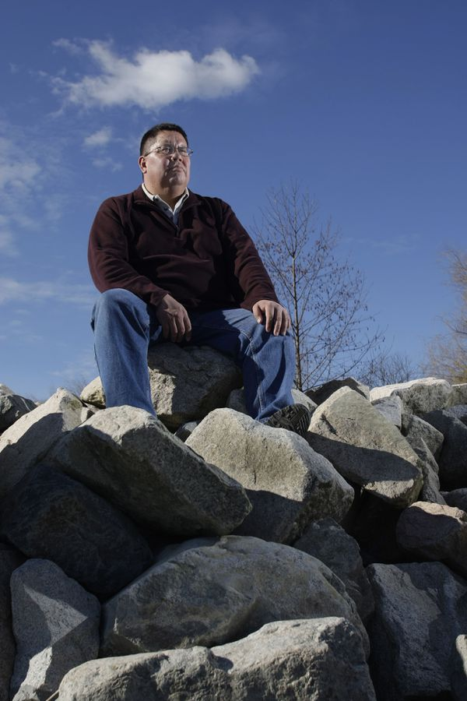
Doug Kelly, shown in 2008, is a former chief of the Sto:lo Tribal Council who helped create Xyolhemeylh.LYLE STAFFORD/FOR THE GLOBE AND MAIL
When former Sto:lo Grant Chief Doug Kelly helped create Xyo back in 1993, he says his vision was far from today’s reality. The guiding approach was: “All the things the government is doing to us and for us, we can do for ourselves.”
The problem with the model quickly became apparent, says Chief Kelly, a formidable voice in child welfare in B.C.: Xyolhemeylh was “just a brown ministry office.” It may be First Nations-run, he says, “but we run it in accordance with policies set by the ministry. Does that work? No, it never has. It hasn’t worked for MCFD. Why would we think it was going to work for us?”
The intent was to run it according to Coast Salish ancestral law and traditions. But the funding formula created perverse incentives, he says. Xyolhemeylh was only paid to apprehend children; there was no funding for prevention.
Mr. Kelly says Xyolhemeylh is being asked to provide the same services as non-Indigenous agencies, with less money and capacity, and fewer resources. Significant funding issues for Indigenous child welfare have been documented, notably the landmark 2016 decision of the Canadian Human Rights Tribunal. It found the federal funding model for Indigenous child welfare was flawed and discriminatory, and violated the Canadian Human Rights Act. A report on the underfunding of Indigenous Child and Family Service agencies by B.C.’s Representative for Children and Youth found that funding shortfalls leave these agencies short-staffed and unable to provide the comprehensive services needed. Social workers it surveyed carried twice the recommended caseload.
Audits for the next three largest Indigenous agencies in B.C. make clear the problems they face are not unique. When it came to “developing a comprehensive plan of care,” Usma Nuu-chah-nulth Family and Child Services on Vancouver Island received a grade of 14 per cent, compared with 11 per cent for Xyolhemeylh. In terms of respecting the rights of the child in care, the Vancouver Aboriginal Child and Family Services Society was graded 35 per cent, compared with 36 per cent for Xyolhemeylh. When it came to ensuring social workers were maintaining contact with the youth in their care, Secwepemc Child and Family Services in Kamloops received a score of 0 compared with 3 per cent for Xyolhemeylh.
Mr. Kelly is furious that Xyolhemeylh is being blamed for Traevon’s death. He is angry that Traevon’s family and several First Nations organizations supporting them have taken their grief to media: “It’s wrong and disrespectful of the chiefs and the agency.”
The Union of B.C. Indian Chiefs, or UBCIC, wants an independent public inquiry so they can answer questions such as why it took four days to find Traevon. Chief Harvey McLeod of the B.C. Assembly of First Nations said the public needs to know what happened and have assurances that actions are being taken to ensure a death like Traevon’s won’t happen again.

